Karla Cruz
1/30/21

Week 4 Assignment

1. (1pt) For each correlation coefficient below, calculate what proportion of variance is shared by the two correlated variables:

- r = 0.25 r² = .0625
- r = 0.33 r²= .1089
- r = 0.80 r²= .64
- r = 0.14 r²= .0196

2. (1pt) For each coefficient of determination below, calculate the value of the correlation coefficient:

- r² = 0.54 r = 0.734
- r² = 0.13 r = 0.360
- r² = 0.39 r = 0.624
- r² = 0.07 r = 0.265

3. (1pt) Suppose a researcher regressed surgical patients’ length of stay (dependent variable) in the hospital on a scale of functional ability measured 24 hours after surgery. Given the following, solve for the value of the intercept constant and write out the full regression equation:

Mean length of stay = 6.5 days; mean score on scale = 33; slope = -0.10
Simple Linear regression equation: Y= a+bX
6.5=a+ (-.10*33)
6.5=a-3.3
+3.3 +3.3
a=9.8

4. (1pt) Using the regression equation calculated in Exercise 3, compute the predicted value of Y (length of hospital stay) for patients with the following functional ability scores:

- X = 42
Y= a+bX
Y= 9.8+(-.10*42)
Y=9.8+ (-.42)
Y=5.6

- X = 68
Y=a+bX
Y=9.8+(-.10*68)
Y=9.8+(-6.8)
Y= 3

5. (4 pts) Reexamine the Fellows Research Group data we used in week 2’s assignment (the excel file is named “Fellows Mental Health Data” and is also in this week’s assignment area). Using this data set again, perform a correlation analysis using the General Practitioner Assessment of Cognition score (“GPCOG”) as a predictor of the Mental Health Survey Score (“MentalHlth”) of all subjects.
- Plot the data with a regression line and perform a regression with the appropriate statistical test in StatCrunch. Copy and paste your graph and regression output into your Word document for full credit.
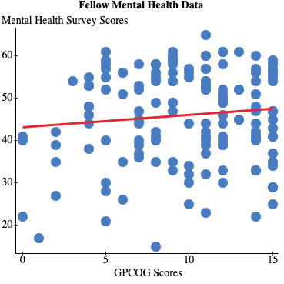

Simple linear regression results:
Dependent Variable: MentalHlth
Independent Variable: GPCOG
MentalHlth = 43.036035 + 0.29198815 GPCOG
Sample size: 150
R (correlation coefficient) = 0.10496464
R-sq = 0.011017575
Estimate of error standard deviation: 10.879158

Parameter estimates:
Parameter | Estimate | Std. Err. | Alternative | DF | T-Stat | P-value
Intercept | 43.036035 | 2.3863377 | ≠ 0 | 148 | 18.034344 | <0.0001
Slope | 0.29198815 | 0.22739748 | ≠ 0 | 148 | 1.284043 | 0.2011

Analysis of variance table for regression model:

Source | DF | SS | MS | F-stat | P-value
Model | 1 | 195.14152 | 195.14152 | 1.6487665 | 0.2011
Error | 148 | 17516.698 | 118.35607
Total | 149 | 17711.84

- What is the correlation coefficient r and what is the coefficient of determination here? What does the coefficient of determination mean in this case?
Coefficient r = 0.10496464
Coefficient of determination=0.011017575
Indicating a positive relationship between GPCOG scores and mental health survey scores.
The coefficient of determination means there is 1% of the variation in GPCOG scores as a predictor of
Mental Health Survey Score.
- Is there a statistically significant correlation between cognition and mental health in this sample?
The value of .2011 is greater than .05 and the Coefficient r-value 0.10496464 is less than the table value of .174 making the correlation not statistically significant.

- What hypotheses did you test?
H0: There is no relationship between GPCOG scores as a predictor and Mental Health Survey scores.
H1: There is a relationship between GPCOG scores as a predictor and Mental Health Survey scores.

6. (5 pts) According to the University of Chicago, as men age, their cholesterol level goes up. A new drug (XAB) is being tested to determine if it can lower cholesterol in aging males and at what dose. The data for the first test subject is below:
Dose (mg): 2 3 5 6 8 10
Cholesterol level (mg/dL): 310 124 190 110 52 20
- Plot the data with a regression line and perform a regression with the appropriate statistical test in StatCrunch. Copy and paste your graph and regression output into your Word document for full credit.
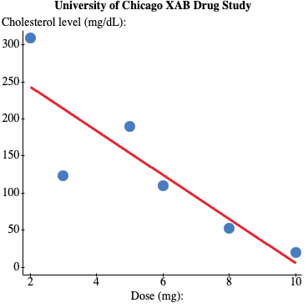

Simple linear regression results:
Dependent Variable: Cholesterol level (mg/dL):
Independent Variable: Dose (mg):
Cholesterol level (mg/dL): = 303 - 29.764706 Dose (mg):
Sample size: 6
R (correlation coefficient) = -0.85838665
R-sq = 0.73682764
Estimate of error standard deviation: 59.884939

Parameter estimates:
Parameter | Estimate | Std. Err. | Alternative | DF | T-Stat | P-value
Intercept | 303 | 56.017231 | ≠ 0 | 4 | 5.40905 | 0.0057
Slope | -29.764706 | 8.8942387 | ≠ 0 | 4 | -3.3465153 | 0.0287

Analysis of variance table for regression model:
Source | DF | SS | MS | F-stat | P-value
Model | 1 | 40162.51 | 40162.51 | 11.199165 | 0.0287
Error | 4 | 14344.824 | 3586.2059
Total | 5 | 54507.333

Predicted values:
X value | Pred. Y | s.e.(Pred. y) | 95% C.I. for mean | 95% P.I. for new
7 | 94.647059 | 27.172348 | (19.204528, 170.08959) | (-87.935445, 277.22956)

- What is the correlation coefficient r and what is the coefficient of determination here? What does the coefficient of determination mean in this case?
Correlation coefficient r =-0.85838665
Coefficient of determination =0.73682764 this correlation also indicates a negative association.
The coefficient of determination means 74% of the variation we see in the reduction of cholesterol can be explained by taking the new drug XAB.
- Is there a statistically significant correlation between the dose and cholesterol in this sample?
The pvalue of .0287 is less than .05, and the Correlation coefficient r-value of -0.85838665 is greater than the table value of .811 making the correlation statistically significant.

- What hypotheses did you test?
H0: There is no relationship between taking drug XAB and reducing cholesterol levels.
H1: There is a relationship between taking drug XAB and reducing cholesterol levels.

- Using StatCrunch, what is the predicted cholesterol level for a person taking a dose of 7 mg? Copy and paste your regression output from StatCrunch into your Word document for full credit.
The predicted cholesterol level for a person taking a dose of 7 mg is 94.647059.

Predicted values:
X value | Pred. Y | s.e.(Pred. y) | 95% C.I. for mean | 95% P.I. for new
7 | 94.647059 | 27.172348 | (19.204528, 170.08959) | (-87.935445, 277.22956)

7. (5 pts) A study by the University of Montreal examined a new test to deepen the evaluation of mental states through the creation and validation of a practical measure, the Mental States Task (MST). The researchers examined many factors including age and the valid and reliable PANAS test. The data is in an excel file named “Montreal_Study_on_Mental_States” and is also in this week’s assignment area. Using this data set, perform a correlation analysis using the subject’s age (“AGE”) as a predictor of their PANAS score (“PANAS”) of all the subjects.
- Plot the data with a regression line and perform a regression with the appropriate statistical test in StatCrunch. Copy and paste your graph and regression output into your Word document for full credit.
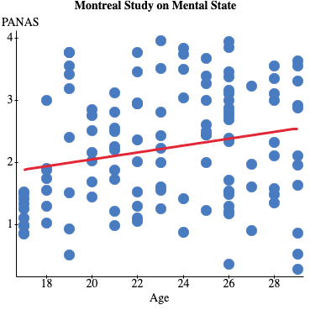

Simple linear regression results:
Dependent Variable: PANAS
Independent Variable: age
PANAS = 0.93798014 + 0.055259298 age
Sample size: 125
R (correlation coefficient) = 0.21675735
R-sq = 0.046983747
Estimate of error standard deviation: 0.93691191

Parameter estimates:

Parameter | Estimate | Std. Err. | Alternative | DF | T-Stat | P-value
Intercept | 0.93798014 | 0.52767125 | ≠ 0 | 123 | 1.7775843 | 0.0779
Slope | 0.055259298 | 0.022440325 | ≠ 0 | 123 | 2.4624999 | 0.0152

Analysis of variance table for regression model:

Source | DF | SS | MS | F-stat | P-value
Model | 1 | 5.3229204 | 5.3229204 | 6.0639059 | 0.0152
Error | 123 | 107.96988 | 0.87780393
Total | 124 | 113.2928

Predicted values:

X value | Pred. Y | s.e.(Pred. y) | 95% C.I. for mean | 95% P.I. for new
23 | 2.208944 | 0.083940014 | (2.0427899, 2.3750981) | (0.34695614, 4.0709318)

- What is the correlation coefficient r and what is the coefficient of determination here? What does the coefficient of determination mean in this case?
Correlation coefficient r =0.21675735
Coefficient of determination =0.046983747 this correlation indicates a positive association.
The coefficient of determination means 5% of the variation we see in the PANAS score can be explained by age.

- Is there a statistically significant correlation between age and the PANAS score in this sample?
The p-value 0.0152 is less than .05 and the Correlation coefficient r value of 0.21675735 is greater than the table value of .195 making this statistically significant.

- What hypotheses did you test?
H0: There is no relationship between age and PANAS Score.
H1: There is a relationship between age and PANAS Score.

- Using StatCrunch, what is the predicted PANAS score for a subject that is 23 years old? Copy and paste your regression output from StatCrunch into your Word document for full credit.
The predicted PANAS score for a subject that is 23 years old is 2.208944.

Predicted values:

X value | Pred. Y | s.e.(Pred. y) | 95% C.I. for mean | 95% P.I. for new
23 | 2.208944 | 0.083940014 | (2.0427899, 2.3750981) | (0.34695614, 4.0709318)

8. (1pt) Use the multiple regression equation below for predicting graduate GPA for the two subjects below:

Y′ = -1.636 + 0.793(undergrad GPA) + 0.004(GREverbal) – 0.0009(GREquant) +0.009(Motivation)

Subject | undergrad GPA | GREverbal | GREquant | Motivation
1 | 2.9 | 560 | 540 | 55
2 | 3.2 | 550 | 590 | 65

Subject 1:
Y= -1.636+0.793(2.9) + 0.004(560) – 0.0009(540) +0.009(55)
Y= -1.636+2.2997+2.24-.486+.495
Y=2.9127
Subject 2:
Y= -1.636+0.793(3.2) + 0.004(550) – 0.0009(590) +0.009(65)
Y=-1.636+2.5376+2.2-.531+.585
Y=3.1556

9. (1pt) Using the following information for R², k, and N, calculate the value of the F statistic for testing the overall multiple regression equation and determine whether F is statistically significant at the 0.05 level:

- R² = 0.13, k = 5, N = 120
F= (.13/5)/((1-.13)/(120-5-1))
F=.026/((.87)/(114))
F=.026/.0076
F=3.421
The F value of 3.421 is greater than the table value of 2.45 making the results statistically significant.

- R² = 0.18, k = 3, N = 64
F= (.18/3)/((1-.18)/(64-3-1))
F=.06/((.82)/(60))
F=.06/.01367
F=4.389
The F value of 4.389 is greater than the table value of 2.76 making the results statistically significant.

